**ANNA UNIVERSITY, CHENNAI – 600 025.**

**DEPARTMENT OF INFORMATION SCIENCE AND TECHNOLOGY**

**MCA (SS) 3 – YEAR PROGRAM**

**BATCH – 2**

**Title:** Procure To Pay (P2P) NAME: HARI VISWESH S

Project Guide: S.KANIMOZHI REG NO: 2019272009

**ABSTRACT:**

P2P platform will be platform enabling determining appropriate Inventory needs based on demand/forecast and the subsequent Procurement, Invoicing and Payment processes. Demand forecasting is the process of using predictive analysis of historical data to estimate and predict customers' future demand for a product. Demand forecasting helps the business make better-informed supply decisions that estimate the total sales and revenue for a future period of time. Based on Demand forecasting output, Procurement system will process of sourcing and purchasing goods from an external source, like a third-party vendor or supplier. It will help to procure goods with limited resources and reduced capabilities. Finally accounting system controlled all invoice & Payment documents between third-party vendor or supplier and P2P. It will produce discrepancies and shows 3-way match like quantity ordered, received, and billed.

**INTRODUCTION:**

**DOMAIN:** Supply chain

A supply chain is an entire system of producing and delivering a product or service, from the very beginning stage of sourcing the raw materials to the final delivery of the product or service to end-users.

* The procure-to-pay (P2P) process combines a company’s procurement and accounts payable functions. The process starts when the need arises for goods or services and ends with the payment for those goods or services.
* The Purchase Order Process:
  + Purchase requisitions are created and approved.
  + Vendors are evaluated and selected.
  + Purchase orders are issued for the required goods and services.
  + The Receiving Process, during which:
  + Goods and services are received or executed.
  + For goods, receiving documents are reviewed and logged.

The Invoice Approval Process:

* Invoices are received and invoice processing completed.
* Invoices are reconciled and cross-checked with the original PO and goods receipts or receiving documents (three-way matching).
* Errors are recorded and corrected.
* Approved invoices are paid

**PROBLEM STATEMENT:**

Rushing to Place Orders

* In some cases, your purchasing department might place an order with a preferred vendor without checking with others to look for discounts or special offers.
* If this is the case, your business might be spending more on essentials items than it needs to pay. You want to have a way for your company to price check your top purchases and comparison shop vendors without wasting a lot of time or sacrificing quality.

Negotiating With Vendors

* When you need materials or stock in your warehouse, it’s easy to just place the order and move on. However, as part of the procure to pay cycle, you want to get the supplies and raw materials for a price that helps you get the most bang for your budget.

Mistakes in Ordering

* Whether your warehouse manager places orders online or handwrites them as the first step in the procure to pay cycle, there is always the chance that the wrong item can get ordered. It’s possible that the wrong number of an item gets ordered.
* This crucial first step in the procure to pay cycle can have an effect on the other steps if not resolved immediately. It helps to have a good working relationship with all of your suppliers to resolve a mistake without it turning into a big deal.

**Architecture Diagram:**

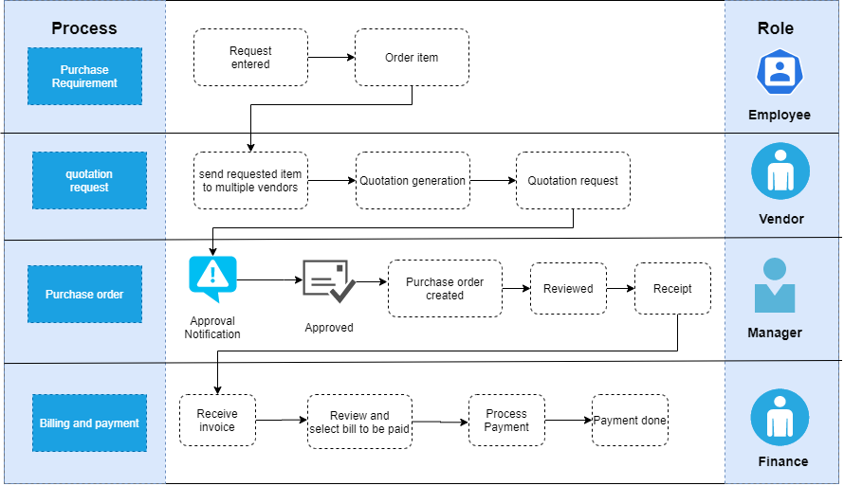

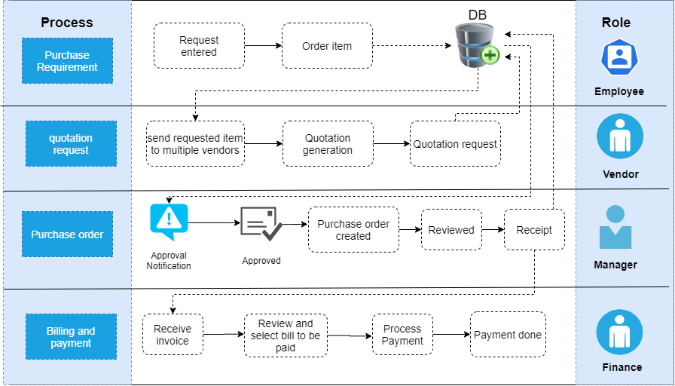

**MODULE:**

* Create Purchase Requisition.
* Generate Purchase Order.
* Receive Purchase Order Approval.
* Issue Goods Receipt.
* Receive and Review Vendor Invoice.
* Approve Vendor Invoice.
* Pay Vendors through Accounts Payable.

**BRIEF DESCRIPTION OF MODULES:**

**Create Purchase Requisition:**

Next, once the department that wants the purchase decides on the vendor, cost, scope and timeline, that department must submit a purchase requisition—i.e., a formal request to make a purchase—to accounting. The purchase requisition remains within the buyer’s company and does not pass to the vendor.

**Generate Purchase Order:**

Once the department has created and submitted a purchase requisition—and accounting has approved it—a [document called the purchase order (PO)](https://www.mhcautomation.com/blog/what-is-a-purchase-order/) goes to the vendor. A PO is a document sent to a vendor stating the scope of work being agreed upon. Both the buyer and vendor must approve this document.

### Receive Purchase Order Approval

Next, the purchase order must be approved by various stakeholders. The first party that needs to give the green light to a PO is the buyer’s accounting team. Often, purchase orders are rejected and must go back and forth within the organization until all of the information is correct. Once the necessary teams on the buyer’s side have signed off, the vendor receives the purchase order and must then agree to it.

### Issue Goods Receipt

Once the buyer has actually received the goods that they’ve requested, they’ll then check the quality of the order: Did the vendor ship the right number of products? Is the product itself in good condition? If these sorts of things are in order, then the buyer will issue a goods receipt. The goods receipt triggers a couple of actions:

### Receive and Review Vendor Invoice

After the services or goods requested have been completed or received, the vendor will then send an invoice. This invoice goes to the accounts payable team who will need to review it to ensure the information lines up with some of the previous documents generated throughout the procure-to-pay process, namely the PO and the goods receipt. This comparison of the three documents—the PO, the goods receipt and the invoice—is [known as three-way matching](https://www.mhcautomation.com/blog/3-way-match-and-accounts-payable/).

### Approve Vendor Invoice

If everything checks out after three-way matching, then the invoice can officially be approved. Usually, this requires that the invoice be routed to someone who has the authority to approve invoices. However, teams that still rely on manual processes to route invoices for approval can quickly run into bottlenecks and delays—particularly if the designated approver is out of town or has a backlog of other invoices they’ve yet to approve.

In workflows that leverage AP automation, though, these sorts of roadblocks are easily avoided with processes like automatic approval routing with built-in scripts that reroute invoices to a secondary approver if they haven’t been approved in a certain amount of time. This way, payment can be processed more quickly.

### Pay Vendors through Accounts Payable

The accounts payable team must ensure the vendor invoice lands in the company’s accounting system. Some companies do this process manually, but this approach is prone to human error and is time-consuming.

To eliminate mistakes and speed up the process (thus avoiding late fees) many companies use automation software. This software can use technology such as [optical character recognition (OCR)](https://www.mhcautomation.com/blog/ocr-what-is-optical-character-recognition/) to convert image text into readable files. Without automation, each vendor invoice passes from vendor to accounts payable team to accounting system, then eventually gets paid out. With [P2P automation](https://www.mhcautomation.com/solutions/use-case/procure-to-pay/), it instead goes straight into the accounting system.

**REFERENCES:**

* <https://www.ariba.com/solutions/business-needs/what-is-procure-to-pay>
* https://nanonets.com/blog/procure-to-pay-process/

NAME: HARI VISWESH S **Guided by**

ROLL NO: 2019272009

DEGREE: MCA (SS) 3rd year **(S.KANIMOZHI)**